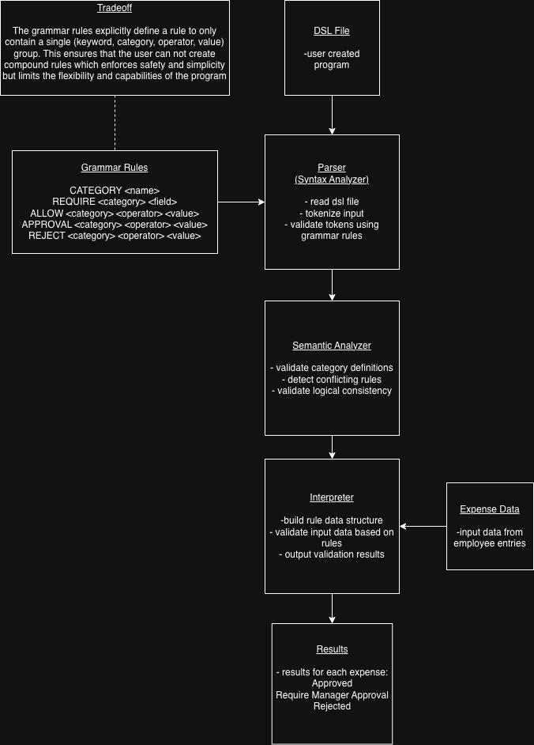
This DSL system was modeled after the design for the paper from this module where the goal was to create a language that could validate expense categories for a small business budget policy. The DSL file that was created by the user is uploaded to the parser along with the grammar rules designed for this specific language. The parser takes the dsl file and parses all of the characters in order to form tokens identified in the grammar rules. It also checks the file for syntax errors according to the grammar rules. This syntax validated data is then sent to the semantic analyzer to ensure that the logic of the statements is correct, no missing or duplicated statements exist, and that rules are assigned to valid categories. Now that the program has been validated for correct syntax and semantics, it is passed to the interpreter section. This section contains multiple parts in order to be used with the expense data that is uploaded. It first builds a data structure such as a dictionary or table to hold all of the categories and their corresponding rules. Once it has this data structure created, it can easily cross reference it as it validates each employee submitted expense. Once all of the expense data has been validated, it outputs the final results. This diagram displays the output directly from the interpreter, but this could also be an API endpoint for the data to be sent to a different system for further processing, organization, and reporting, sent to a database or file for storage, or output to the user directly.
The syntax of the language is stored in the grammar rules and the user created dsl file is validated for its syntax using the parser. The semantics are validated using the specific function created for this sole purpose. It ensures that no duplicate categories exist, rules do not attempt to define a non-existent category, and that all of the conditional logic of the rules is valid.
This language was designed specifically to be used with non-technical employees of a small business. Therefore, simplicity was one of the core design goals. In order to produce an extremely simple format that is also easily protected from poor user designed rules, flexibility and complexity had to be reduced. Categories are singular entities with specific attributes/rules that each have a singular format. This ensures that the syntax and semantic validation processes are able to easily identify errors in the program that would lead to issues with validating expenses. A more complex language may allow for subcategories or connected categories with more complex and compound conditional statements when defining rules. This could allow for more dynamic assignments when validating the expenses. However, it would also remove the protection provided by the syntax and semantic validation steps since the user may create a valid program within these expanded rules, but it could lead to more complex debugging of errors if expenses are being improperly validated.
The diagram above helps to explain the architecture of the system by clearly separating the different sections and functions into individual boxes. This separation helps to clearly understand what parts of the system are performing what actions. The diagram helps to explain the control flow of the system by implementing a top-down structure with arrows guiding the flow along the way. This helps to identify where the output of one section should go to be processed by the following section. Also, the grammar rules and expense data are added into the flow from the sides of the main flow to help differentiate between the main processes and the input data. While the grammar rules are not explicitly input from outside the system like the expense data is, it can still be considered an input to the execution flow when the parser uses it to tokenize and validate the syntax of the dsl file.

